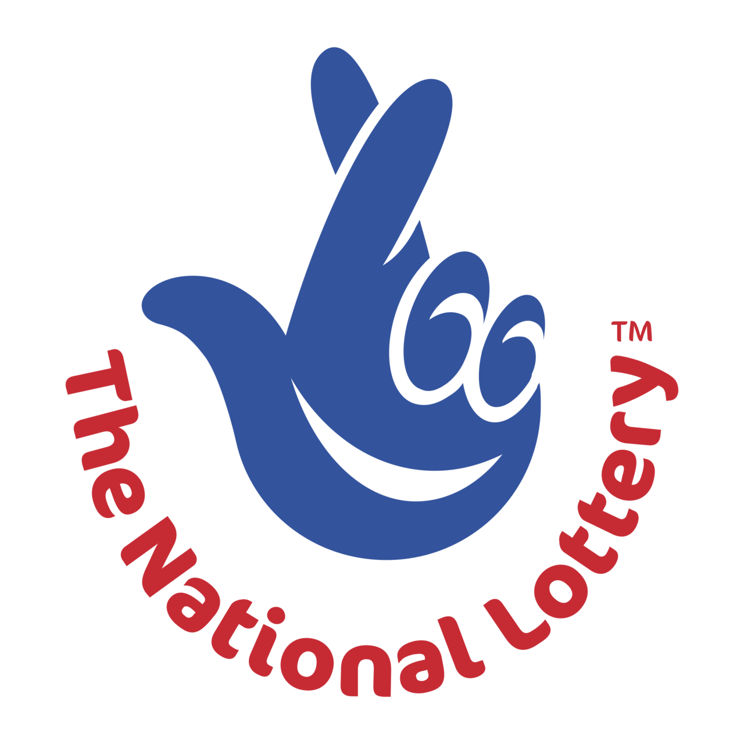

The Community Council have been successful in obtaining National Lottery Funding to assist in reducing our carbon footprint and electricity consumption at the Community Centre. This will be help in making it echo friendly. Thank you also to Councillor Evans for all their work in obtaining this funding.

